EXPORT data from DGSPRO
- Log-on to K5ESK_VILLA schema
- Select “Extras – Datenbankexport” in the menu
- Export Data:
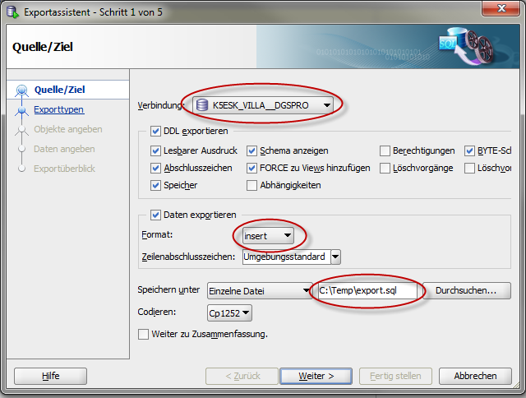
select only these types
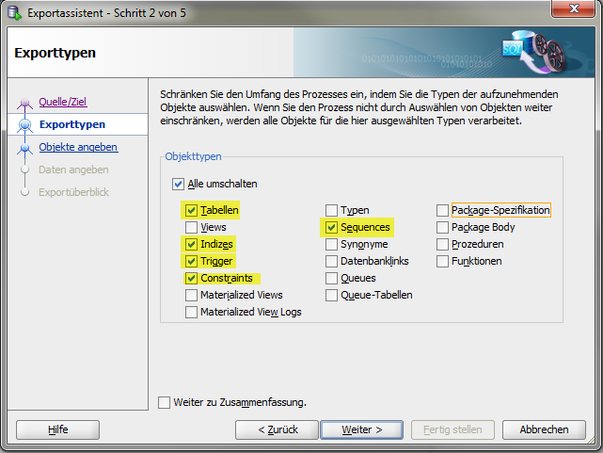
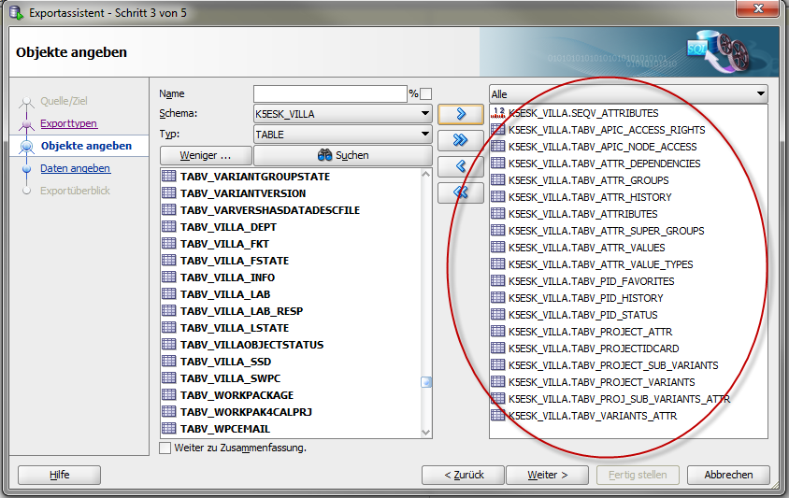
keep defaults in this page
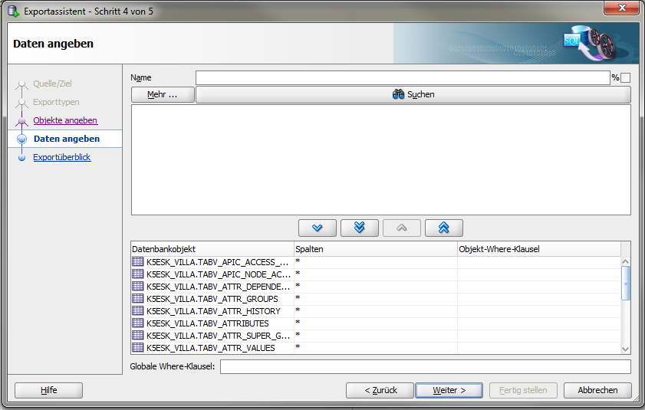
- Replace Schema name in the exportfile:
  - "K5ESK_VILLA". => "DGS_ICDM".
  - K5ESK_VILLA. => DGS_ICDM.
  - "VILLA_TABLE_DEFAULT" => "DGS_ICDM_TS"
  - 'K5ESK_VILLA' => 'DGS_ICDM'

Import data in the new database
- Use SQLPLUS instead of SQLDeveloper because SQLDeveloper will fail
- Connect to the schema in the new database
- If objects are still existing, DROP them:
DROP_ALL_OBJECTS.SQL.TXT
- Execute the exported SQL file
- Check the log messages
- Commit the changes
- Grant access rights to DGS_ICDM_JPA
  - Execute grants.sql
- Log on as DGS_ICDM_JPA
- Create synonyms for DGS_ICDM_JPA
  - Execute synonyms.sql
- If not existing, create the MATERIALIZED VIEWS:

Update data in the new database to version 2.0.0
- Scripts are stored in the directory V1.4.0_to_V2.0.0
- The sequence of Create Trigger and Update Tables needs to be checked!
- Update Trigger
  - Execute create_trigger.sql
- Update Tables
  - Execute Table_Updates.sql
- Migrate Date values
  - Execute MigrateDateValues.sql
- Grant access rights to DGS_ICDM_JPA
  - Execute grants.sql
- Log on as DGS_ICDM_JPA
- Create synonyms for DGS_ICDM_JPA
  - Execute synonyms.sql

